Integrity quality tests in pipeline

Set up unit test project

1. Developers write the code and they will implement some programming logics which as per the requirement
2. What is the guaranty that is logic they have written is correct or not? To do that they will do unit tests
3. Inside the class they will write the methods and inside the methods will write logics as per BRD and this is common in c, c++, phyton
4. For that we need to create the unit test class that means we will create another class where we need to test the logic is correct or not that is called unit class
5. Developer is responsible for writing the class and also responsible for writing the unit test class
6. Both will be in the same language
7. Unit test framework will be available for java, python etc.,
8. We need to move the code as of now we are working in command prompt and in visual studio code just to ease for life we need to use the visual studio dot net and we see the same below

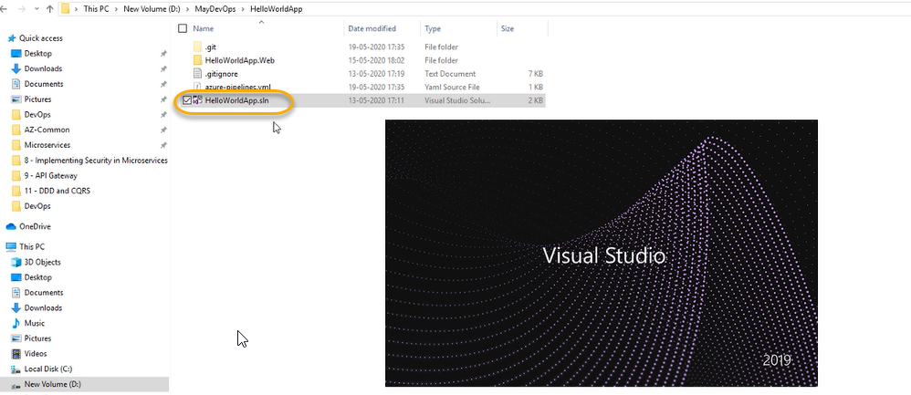

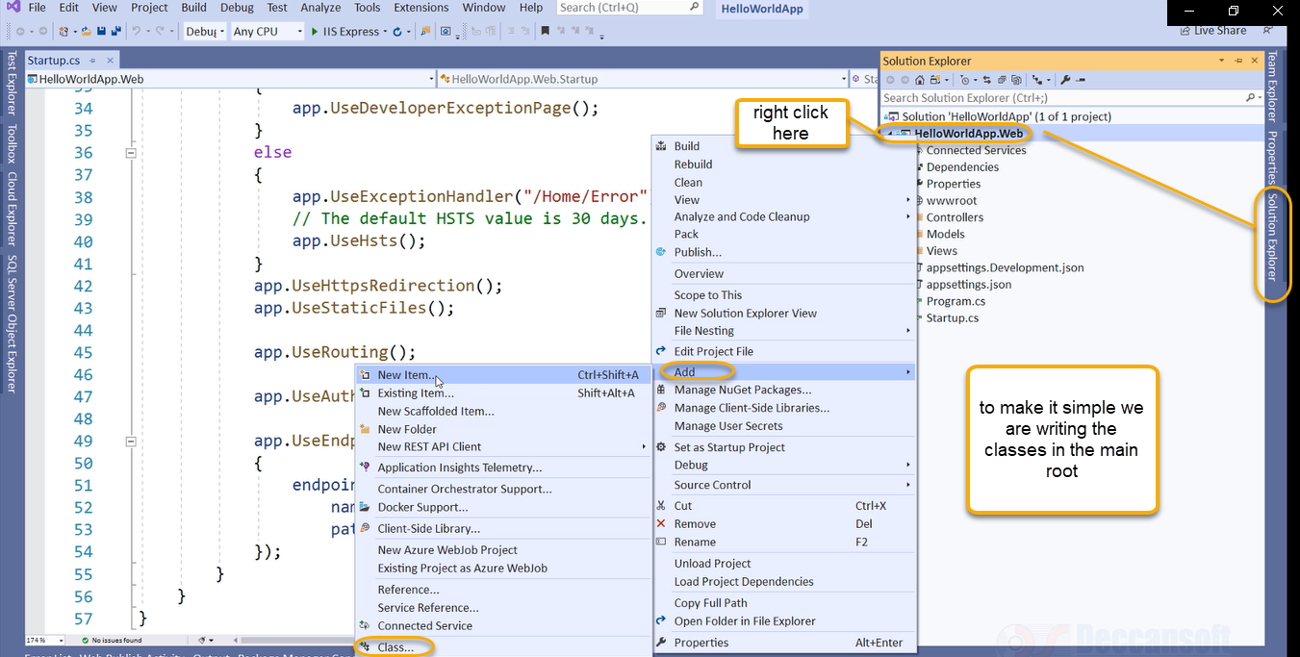

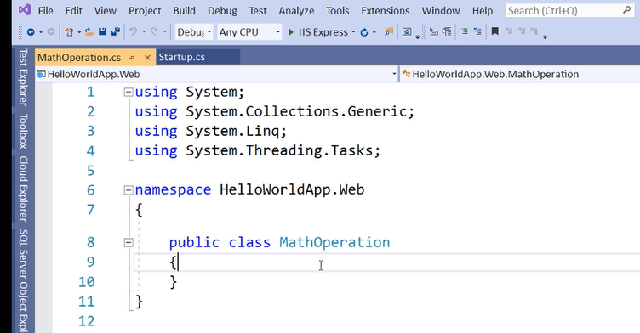

Here in the math operations we will do subtraction and addition

Copy from below image

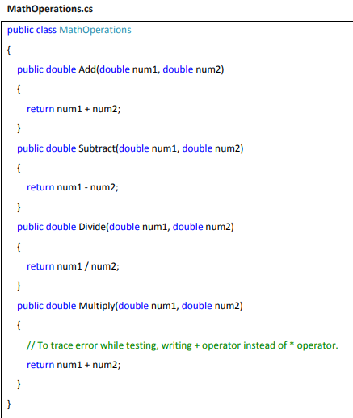

And paste in the below math operation cs

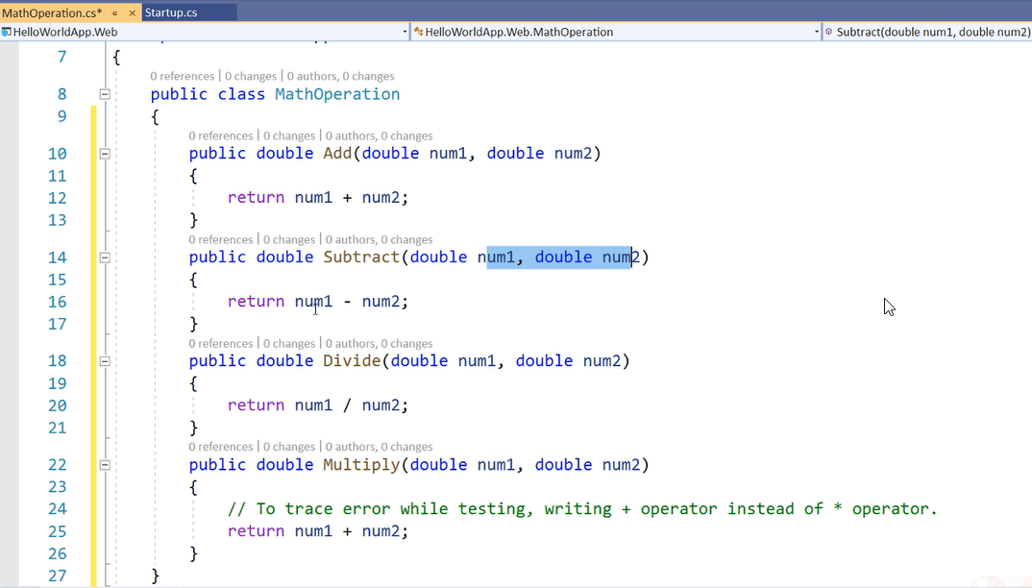

If you want to do through command line prompt

Use the below steps in cmd

dotnet new nunit --name HelloWorldApp.Test

dotnet sln HelloWorldApp.sln add HelloWorldApp.Test\HelloWorldApp.Test.csproj

dotnet add HelloWorldApp.Test\HelloWorldApp.Test

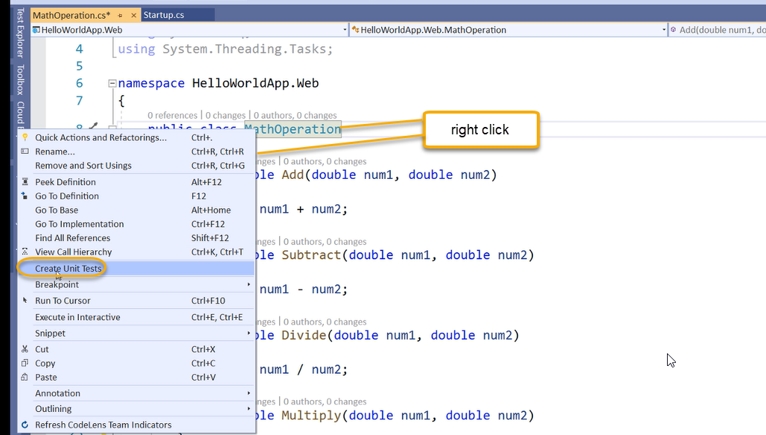

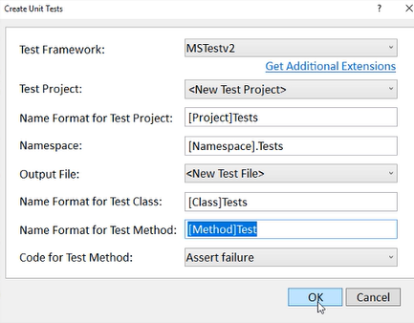

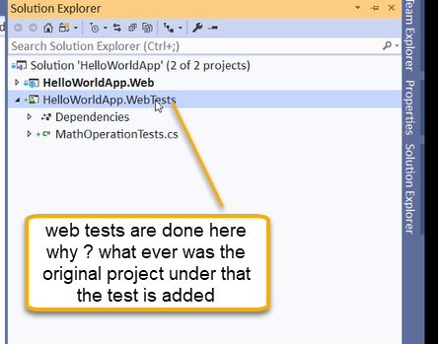

Rename to tests

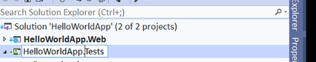

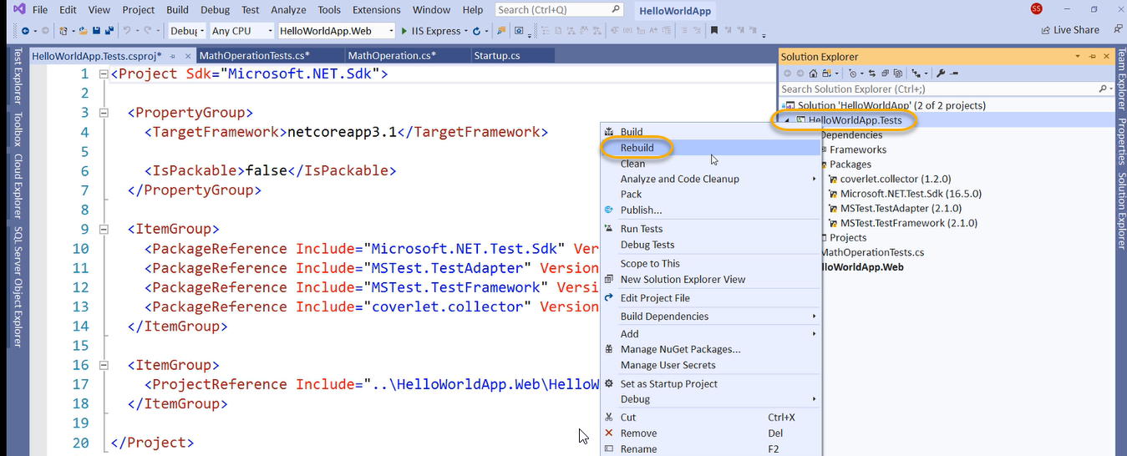

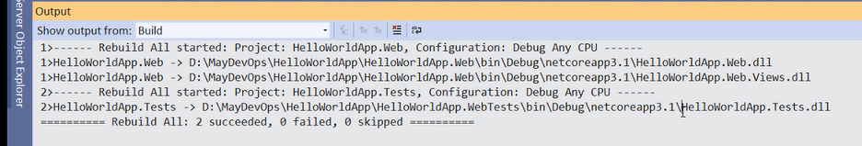

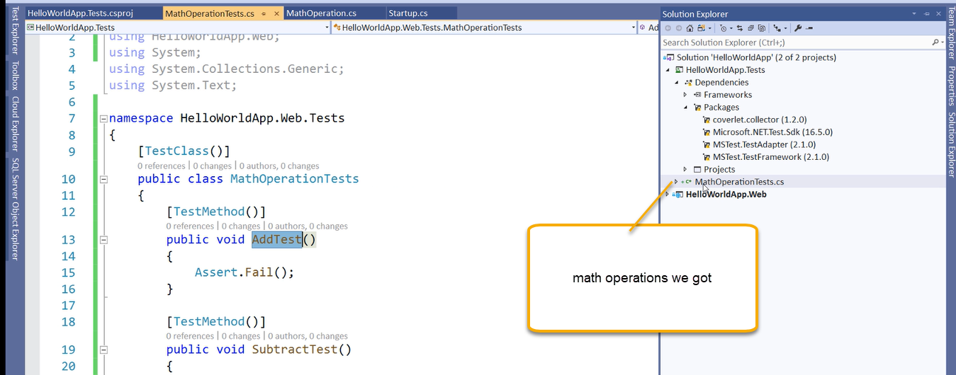

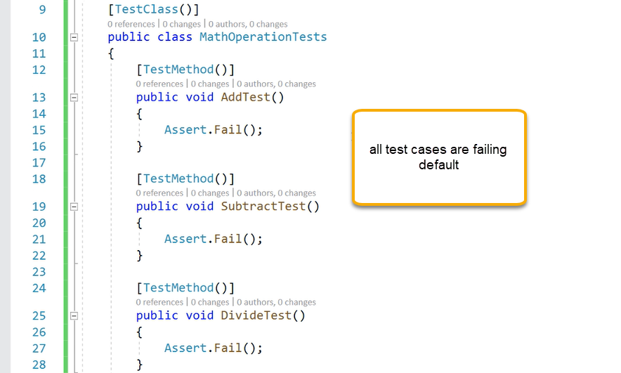

So add the mathematical operations

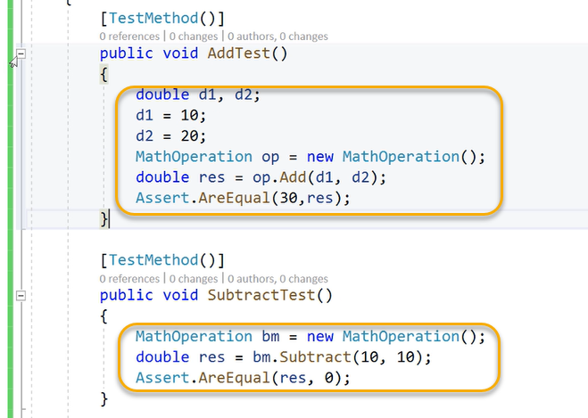

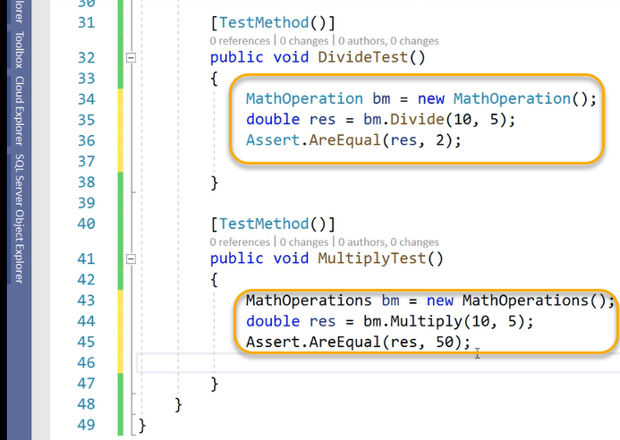

DevOps engineer don’t write unit tests

We need to remove the Helloworldweb.Tests

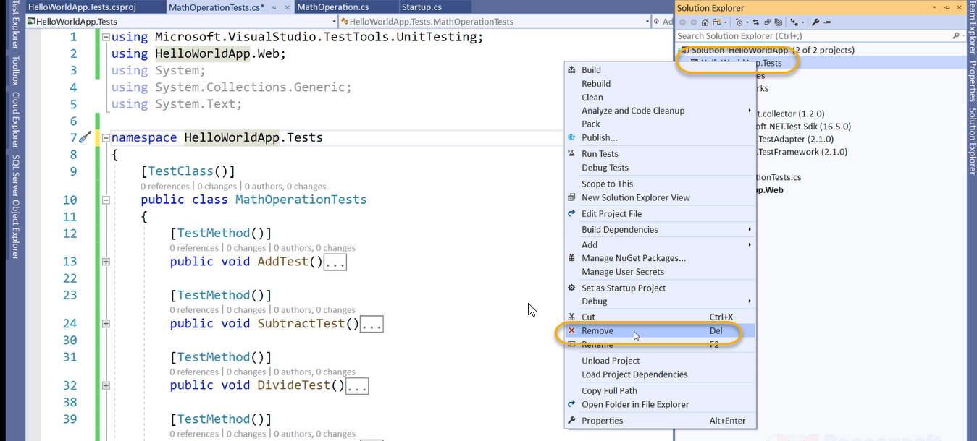

Because locally we still see the HelloworldApp.webTests

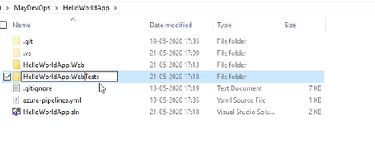

So now rename the HelloworldApp.webTests which is present in locally

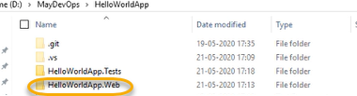

The project is NOT there in visual studio however physically it is there

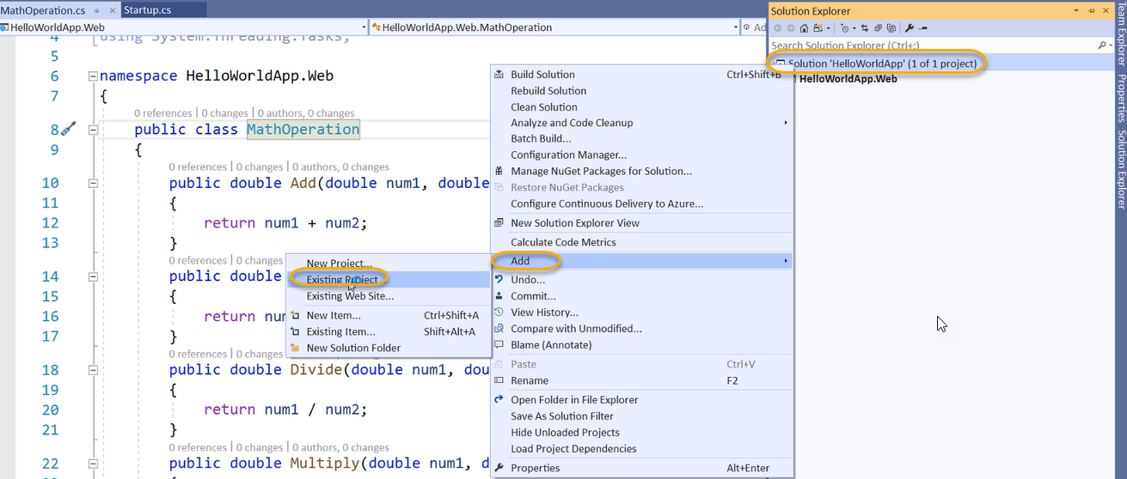

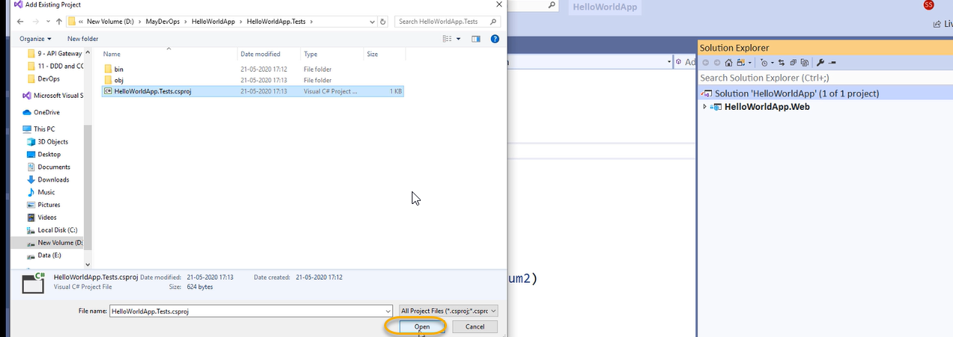

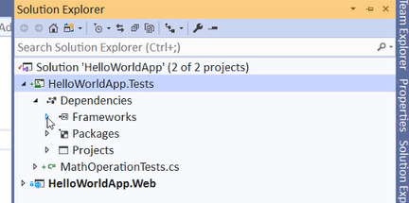

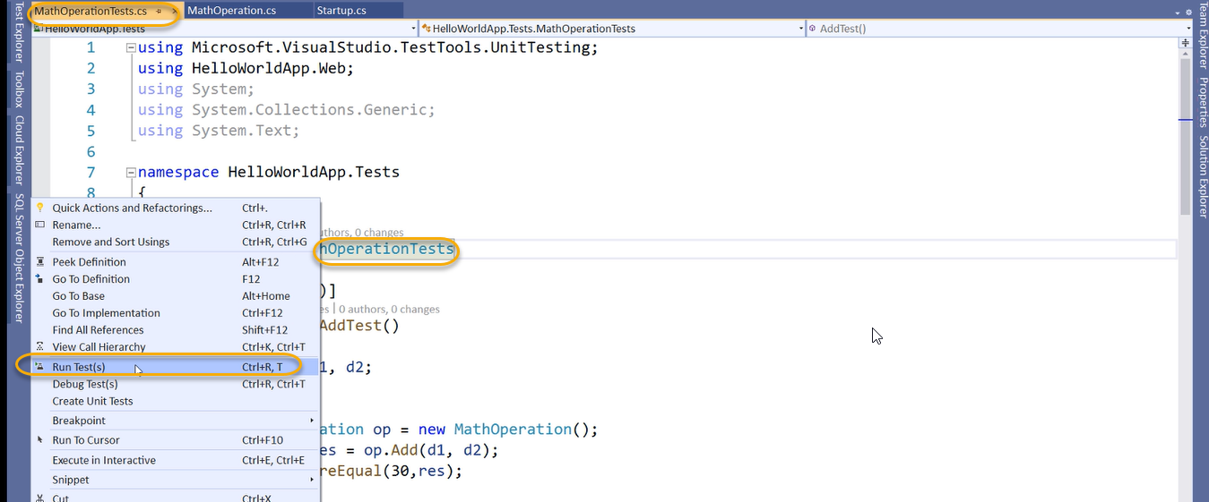

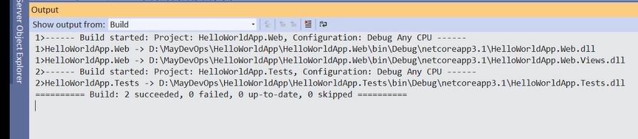

We can see the test results in text explorer

View > text explorer

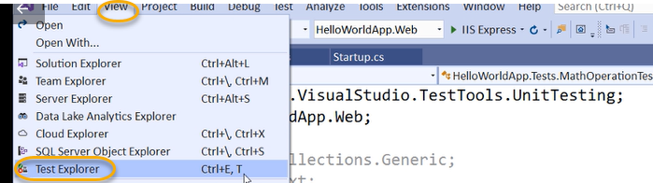

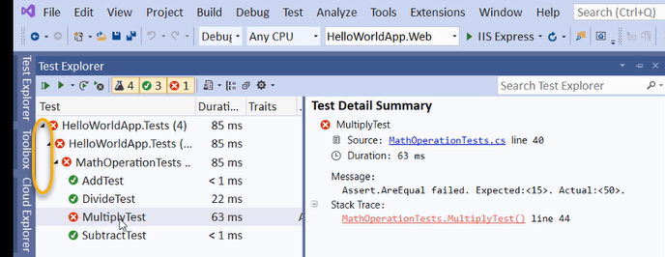

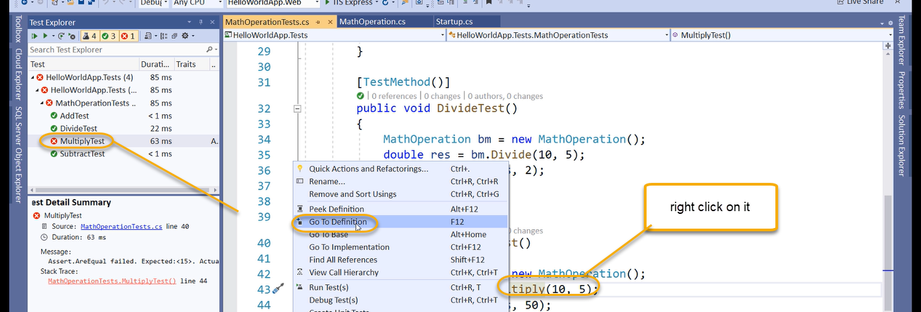

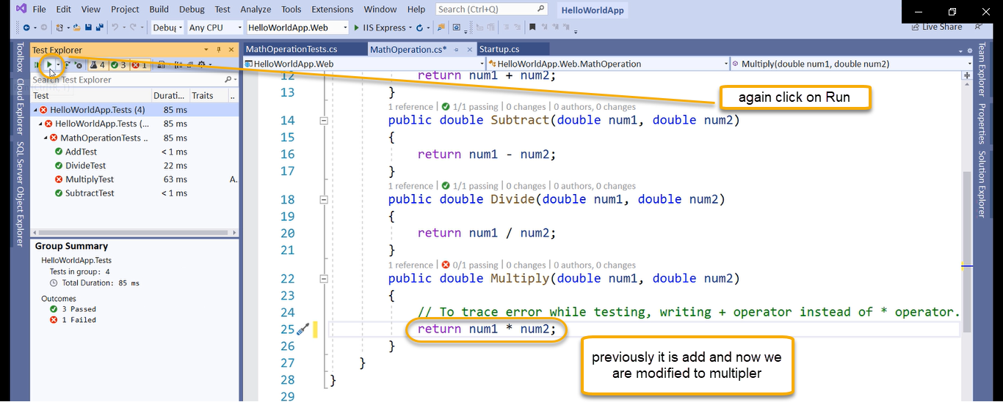

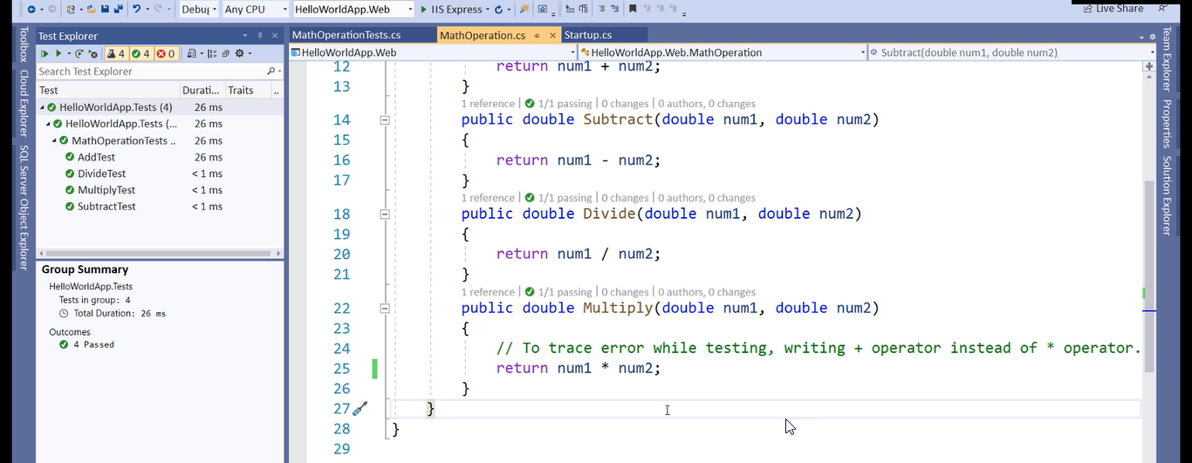

TDD( Test Driven Development) in that even before writing the code the developers write the code and test it the quality

Integrating Unit Test with Classic and YAML Pipeline

1. With Classic

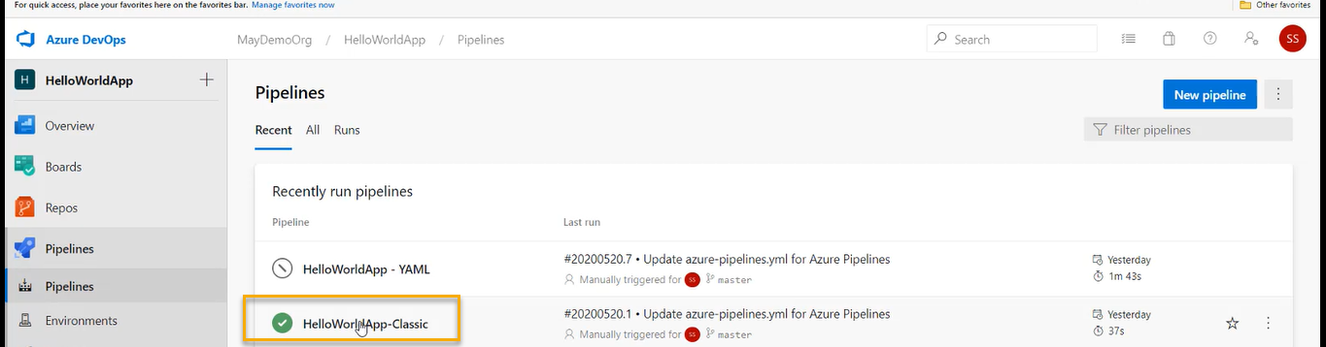

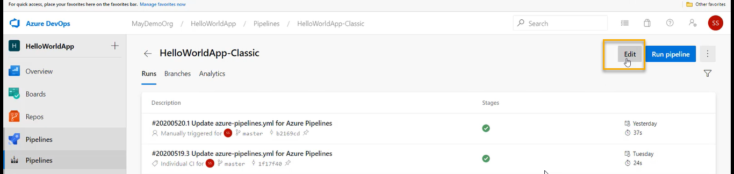

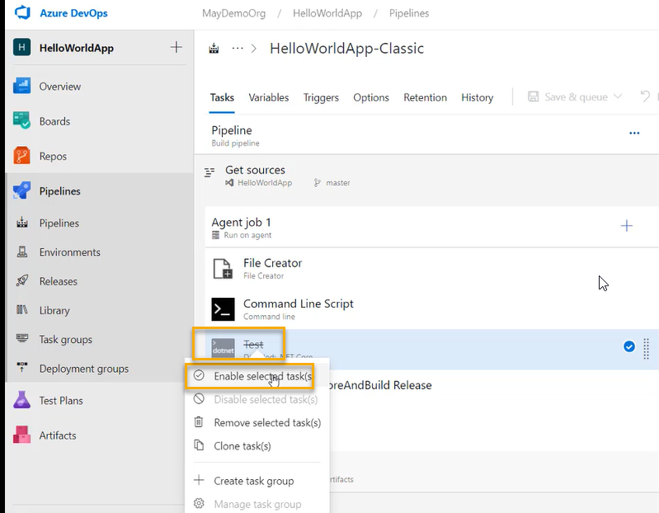

Test is going to invoke unit test project

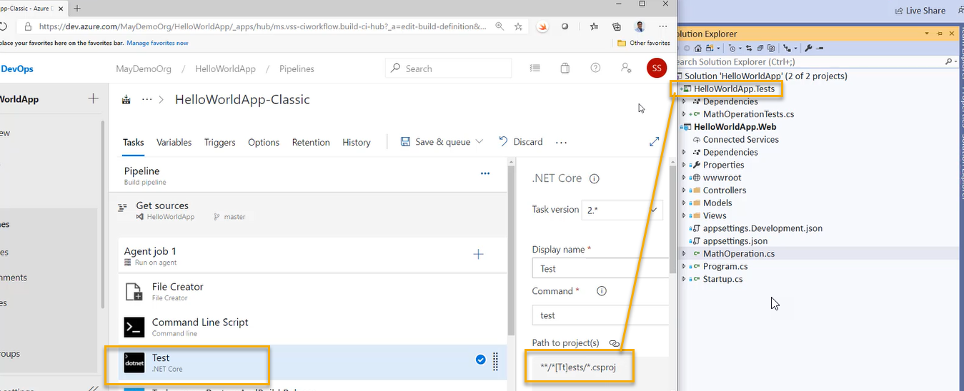

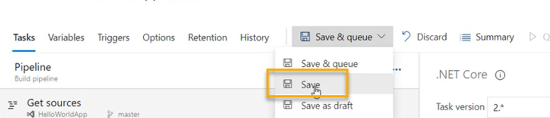

Our new project is in Azure repo if you execute the below ones in cmd

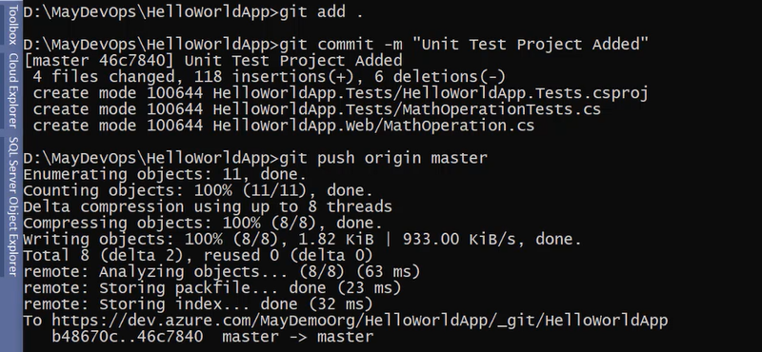

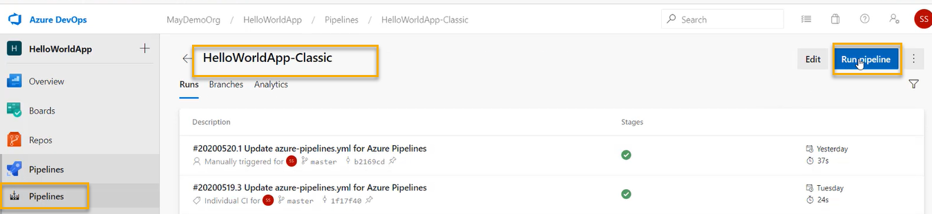

And again click on Run

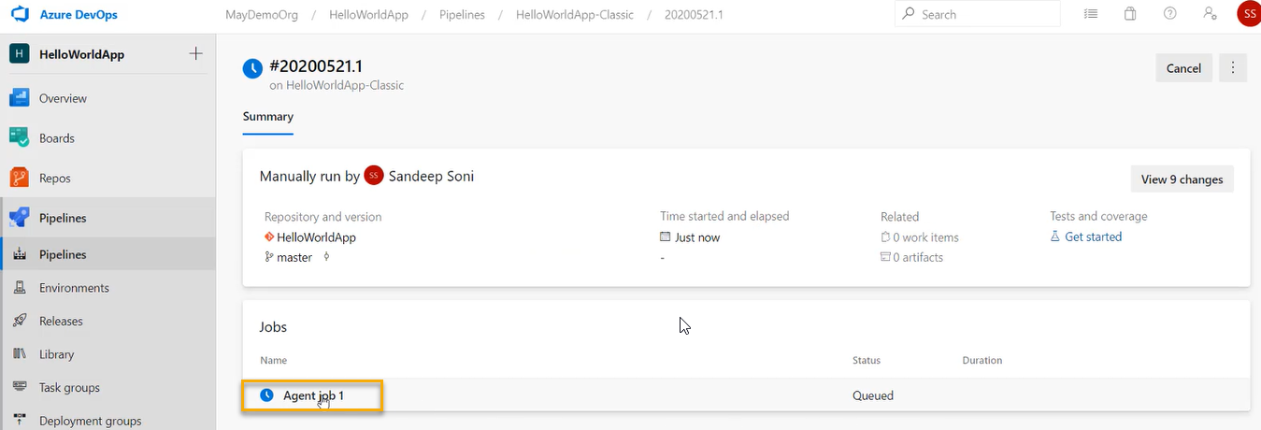

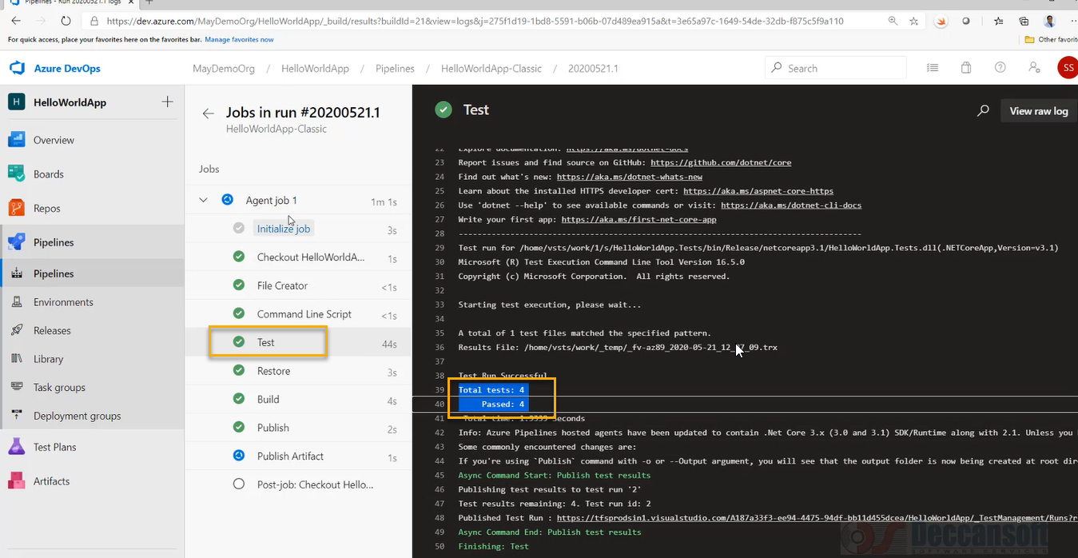

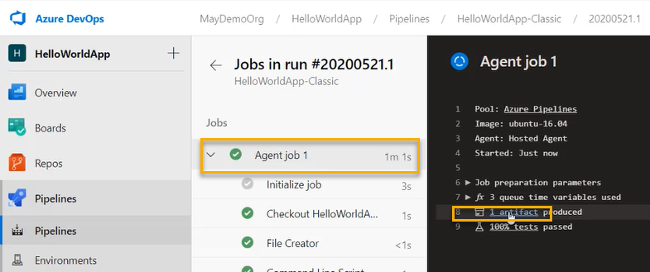

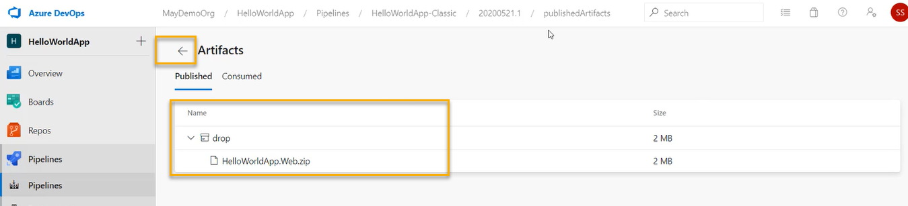

Click on back

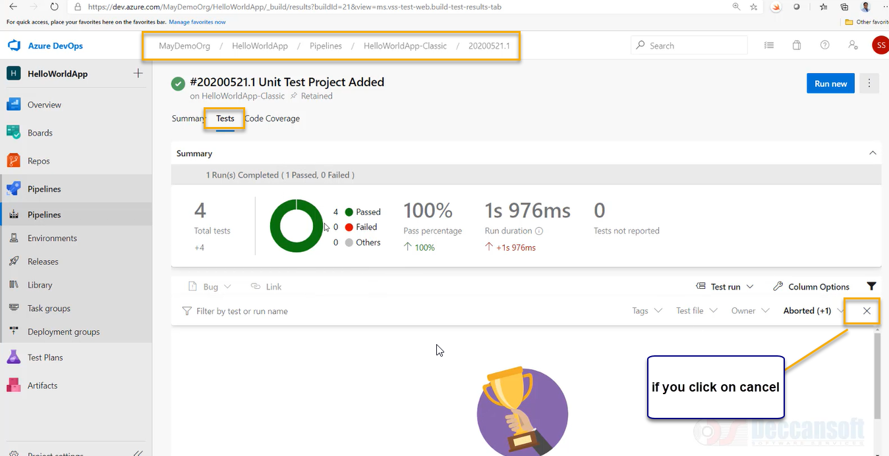

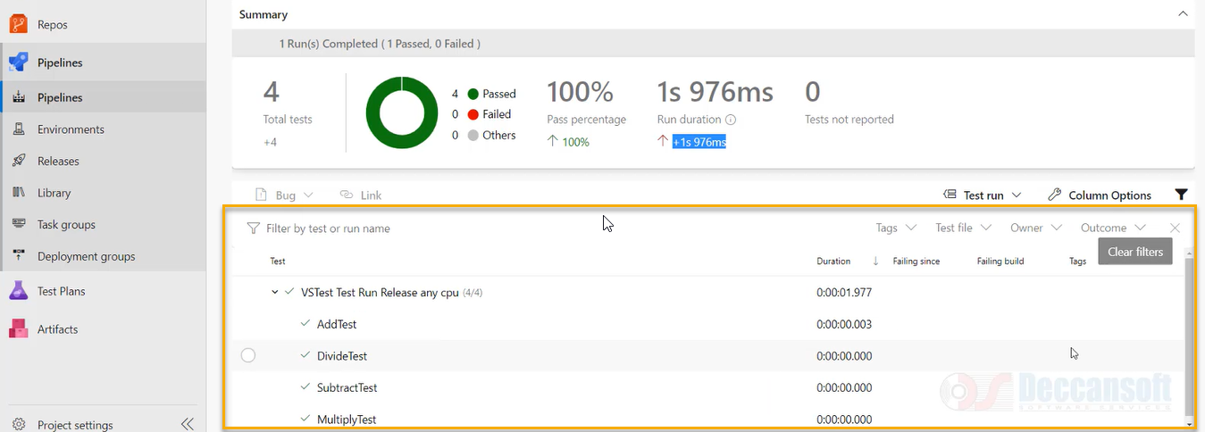

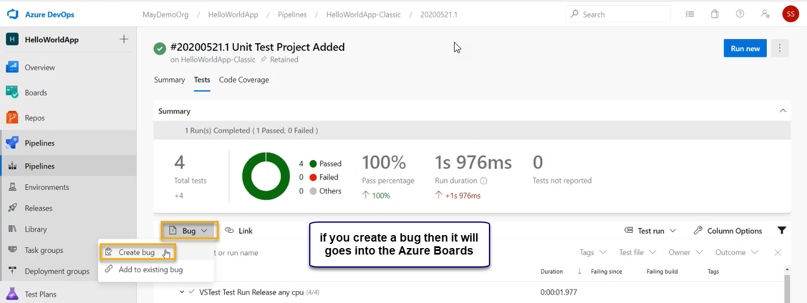

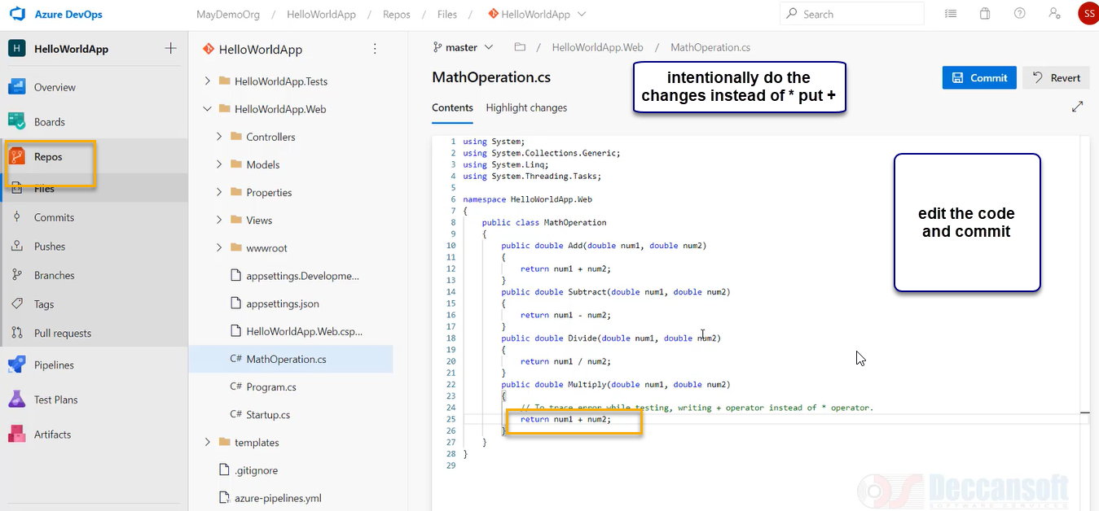

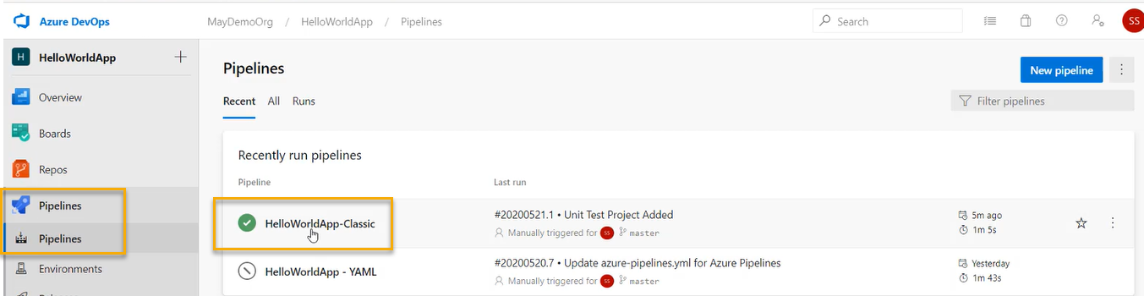

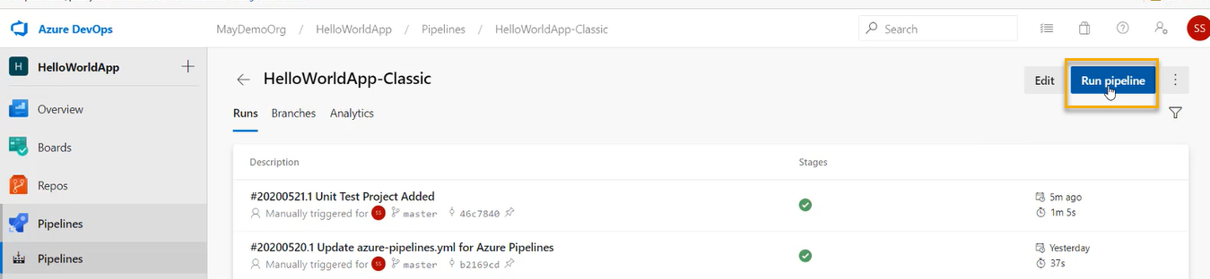

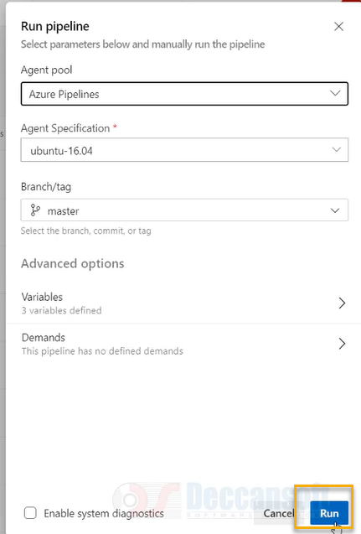

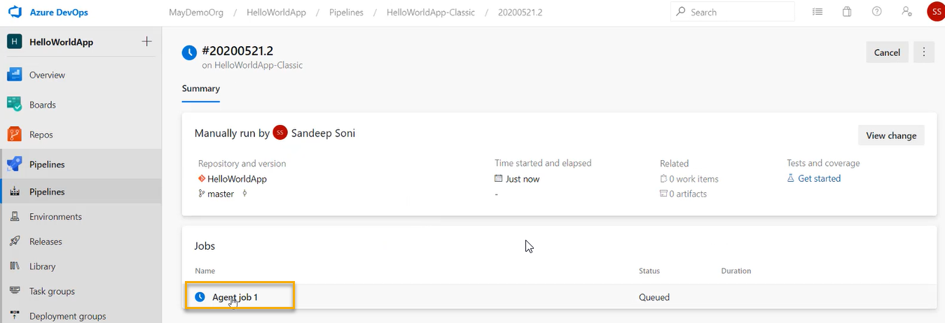

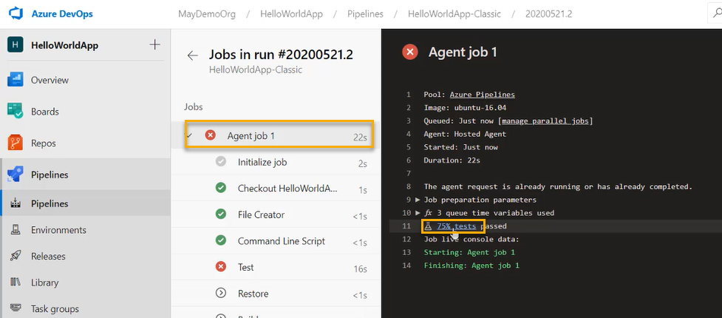

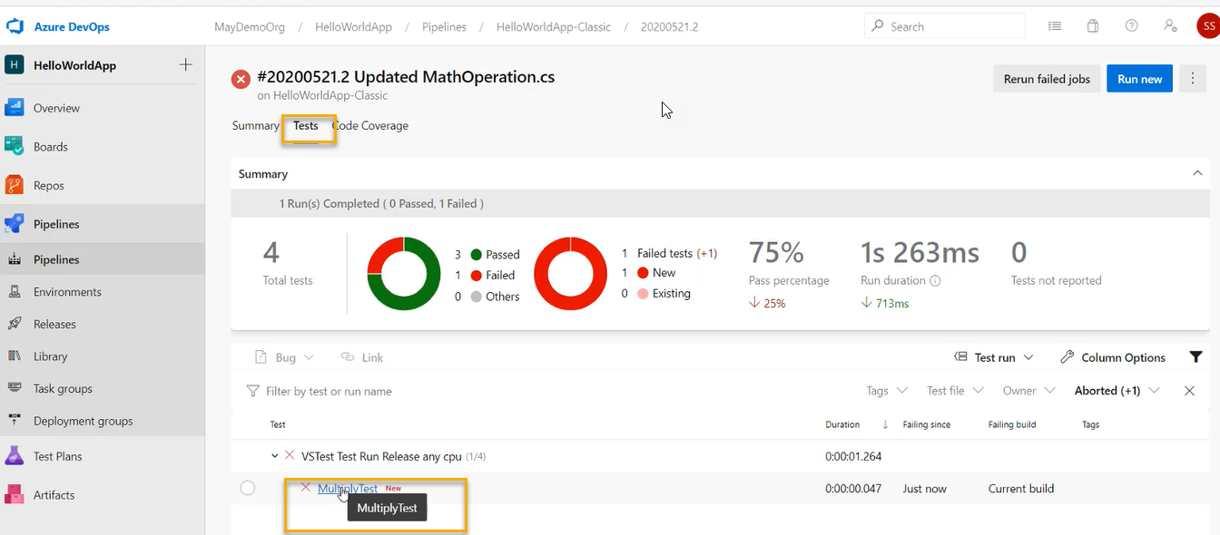

Below are ones which we need to keep in order

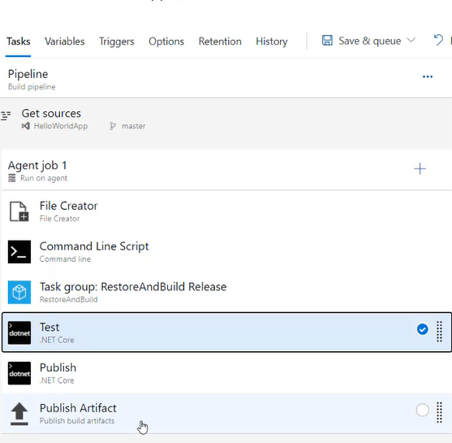

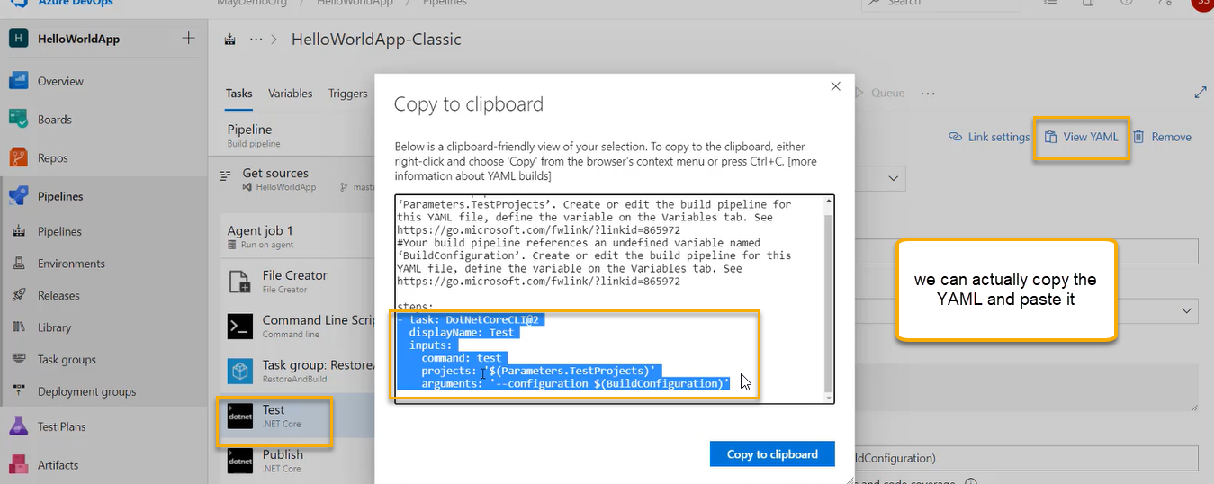

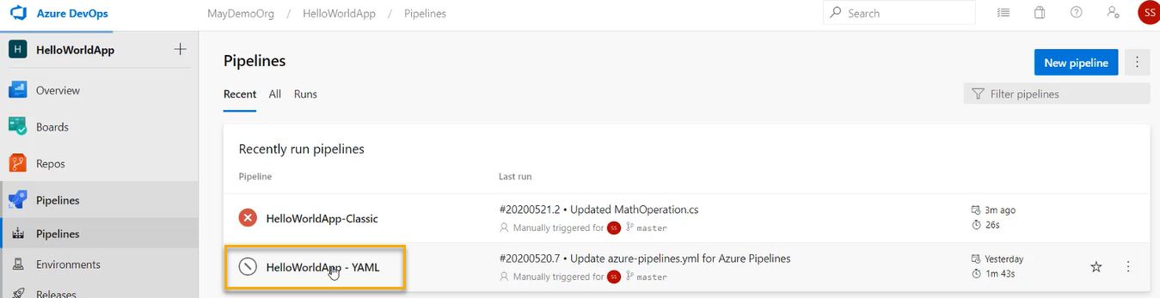

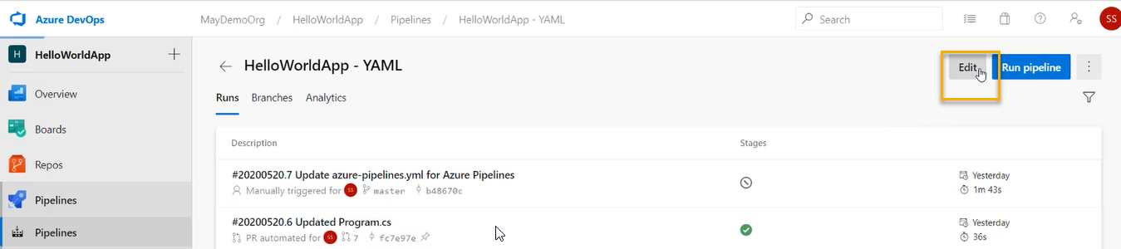

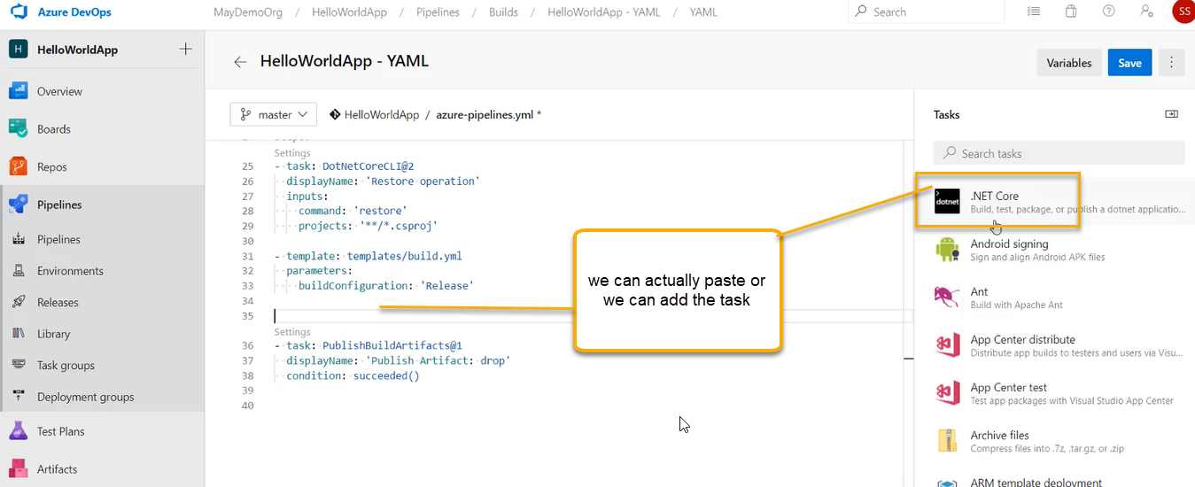

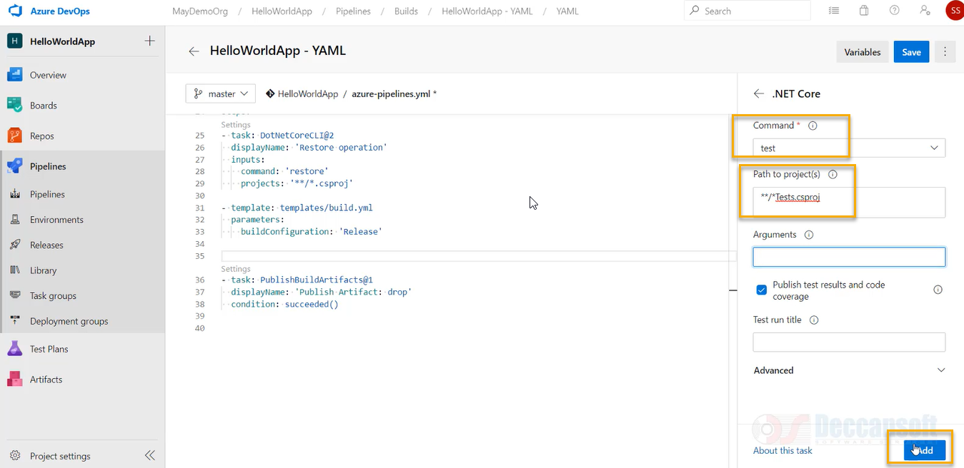

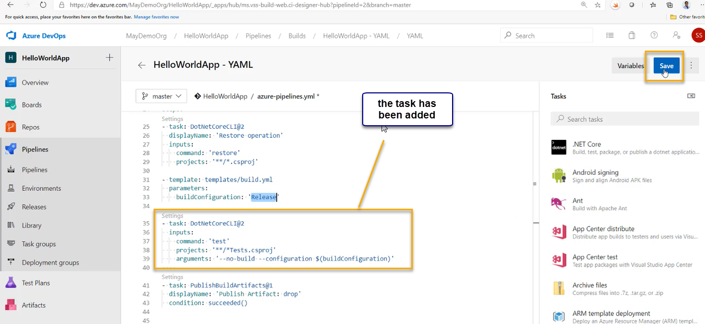

Again click on save

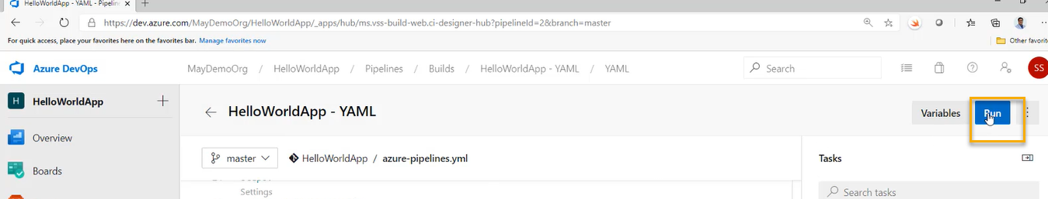

Again click on Run

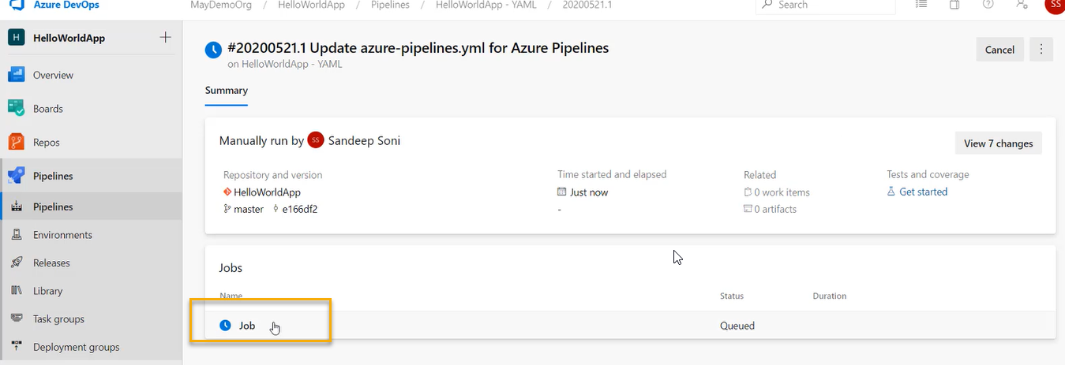

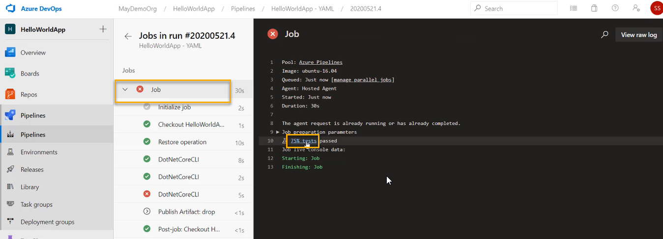

In general if error occurs then he will create a bug and assign to developer and resolve it and then send the pull request and pull request will merge with branch and again whole process will start

All the runs which there are we can in the below navigation

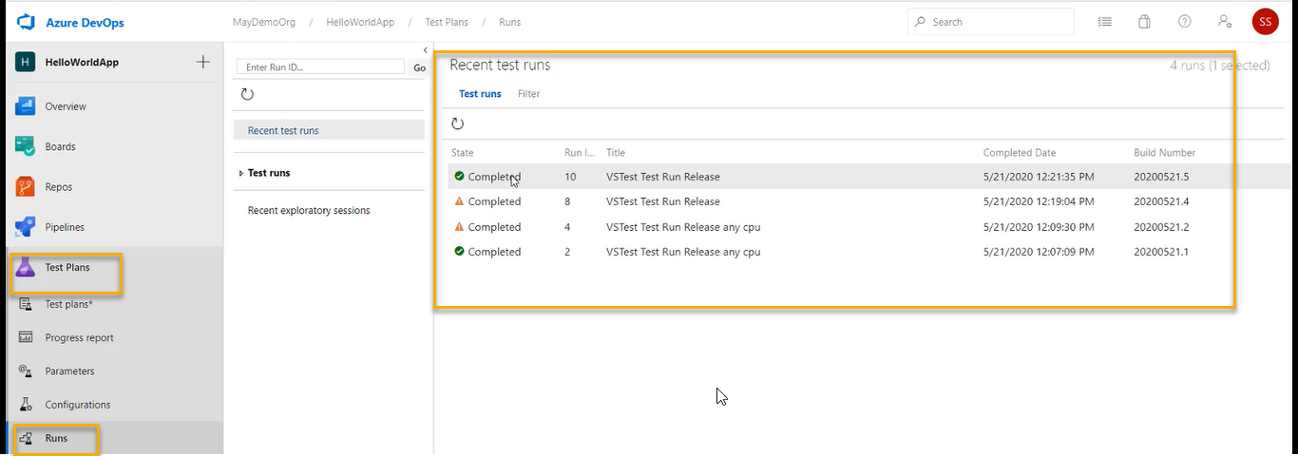

Or we can see in the dashboard

